**Machine Learning Lab CSE 336L**

**Week – 5 K-NN Classifier**

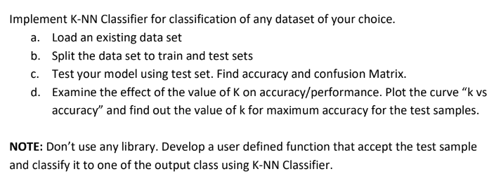

**Code:**

import csv

import random

import math

import matplotlib.pyplot as plt

def load_dataset(filename, split_ratio):

training_data = []

test_data = []

with open(filename, 'r') as file:

lines = csv.reader(file)

dataset = list(lines)

for i in range(len(dataset) - 1):

for j in range(4):

dataset[i][j] = float(dataset[i][j])

if random.random() < split_ratio:

training_data.append(dataset[i])

else:

test_data.append(dataset[i])

return training_data, test_data

def euclidean_distance(instance1, instance2, length):

distance = 0

for i in range(length):

distance += (instance1[i] - instance2[i]) ** 2

return math.sqrt(distance)

def get_neighbors(training_set, test_instance, k):

distances = []

length = len(test_instance) - 1

for i in range(len(training_set)):

dist = euclidean_distance(test_instance, training_set[i], length)

distances.append((training_set[i], dist))

distances.sort(key=lambda x: x[1])

neighbors = []

for i in range(k):

neighbors.append(distances[i][0])

return neighbors

def predict_classification(neighbors):

class_votes = {}

for i in range(len(neighbors)):

response = neighbors[i][-1]

if response in class_votes:

class_votes[response] += 1

else:

class_votes[response] = 1

sorted_votes = sorted(class_votes.items(), key=lambda x: x[1], reverse=True)

return sorted_votes[0][0]

def evaluate_model(test_set, predictions):

correct = 0

confusion_matrix = {}

for i in range(len(test_set)):

actual_class = test_set[i][-1]

predicted_class = predictions[i]

if actual_class == predicted_class:

correct += 1

if actual_class not in confusion_matrix:

confusion_matrix[actual_class] = {}

if predicted_class not in confusion_matrix[actual_class]:

confusion_matrix[actual_class][predicted_class] = 0

confusion_matrix[actual_class][predicted_class] += 1

accuracy = (correct / float(len(test_set))) * 100.0

return accuracy, confusion_matrix

def k_nearest_neighbors(training_set, test_set, k):

predictions = []

for test_instance in test_set:

neighbors = get_neighbors(training_set, test_instance, k)

result = predict_classification(neighbors)

predictions.append(result)

return predictions

filename = "data/iris.csv"

split_ratio = 0.7

k_values = [1, 3, 5, 7, 9, 11]

training_set, test_set = load_dataset(filename, split_ratio)

accuracies = []

for k in k_values:

predictions = k_nearest_neighbors(training_set, test_set, k)

accuracy, confusion_matrix = evaluate_model(test_set, predictions)

accuracies.append(accuracy)

print(f'Accuracy for k={k}: {accuracy:.2f}%')

print('Confusion Matrix:')

for actual_class, pred_classes in confusion_matrix.items():

print(f'Actual: {actual_class}')

for pred_class, count in pred_classes.items():

print(f' Predicted: {pred_class}, Count: {count}')

print('-----------------------------------')

plt.plot(k_values, accuracies)

plt.xlabel('k values')

plt.ylabel('Accuracy')

plt.title('k vs Accuracy')

plt.show()

**Output:**

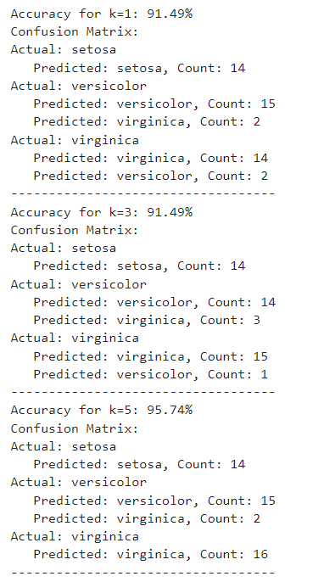 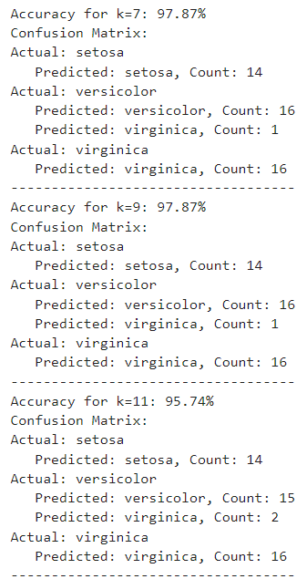

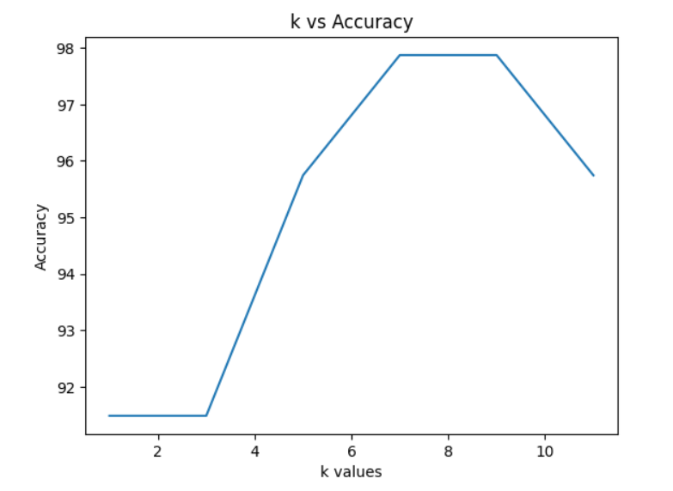

**Submitted By:**

AP21110011080

Kuncham Pavan Vitesh

CSE-Q

Lab Date: 20-Mar -2024